Machine Learning CBC Assignment 2: Decision Trees Algorithm
Lichao Huang, Ning Liu, Xinli Wang, Yufei Wu

1. Implementation Details

In this assignment, we have implemented a decision tree algorithm (ID3 specifically), and made some experiments on the dataset of human facial expressions.

A decision tree algorithm, which is ID3 specifically, is implemented in this assignment. Some experiments on the dataset of human facial expressions are also conducted to test this algorithm.

One of the details that need to be explained is the selection of the best attribute, which determines the growth of a decision tree. In our implementation, we always choose the attribute that results in the highest information gain. More precisely, the information gain, Gain(S,A) of an attribute A, relative to a collection S is defined as

One of the details that need to be explained is the selection of the best attribute, which determines the growth of a decision tree. The attribute with the highest information gain is considered as the best selection in each step of our implementation. More precisely, the information gain, expressed as Gain(S,A) of an attribute A and a collection S, is defined as

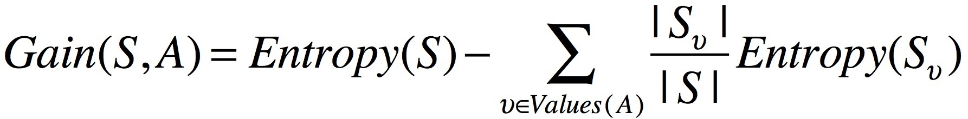.
In this definition, Values(A) is the set of all possible values for A, and S_{𝑣} is the subset of S in which A has value 𝑣. Suppose that p_{i} is the proportion of S belonging to class i. Entropy(S) is then defined as
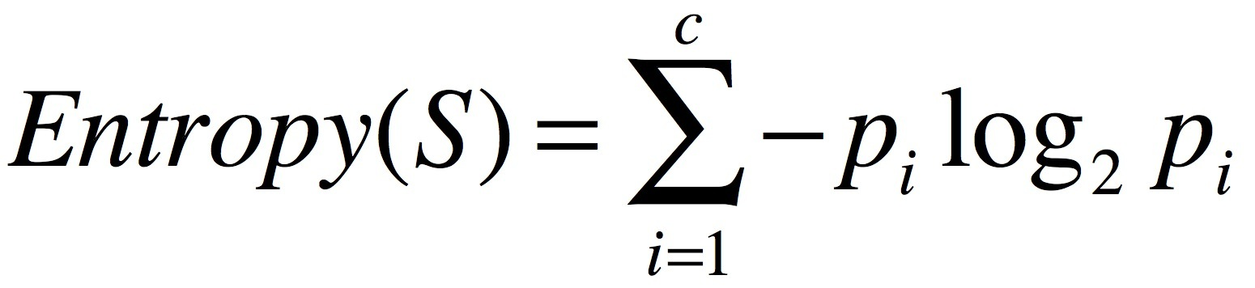.
Specific implementation can be found in the function choose_best_attribute in the matlab file Decision_Tree_Learning.m.

10-fold cross validation is used on datasets to evaluate our decision trees. The whole dataset is split into 10 folds and 9 folds are used for training while one is preserved for test. This process is repeated for 10 times and each time the fold preserved for test is different. Since we do not have to use cross validation to refine parameters in the training process, the 9 folds are all used for training.

We can get 10 tests by performing 10-fold cross validation. After each test we get a confusion matrix, and the final confusion matrix of this dataset is the arithmetic mean of these 10 matrixes. Then we can calculate the average recall and precision rate, the F₁-measures of each class, and the average classification rate of all six basic emotions.

Here is some information about the main functions of our system:

TreeNode.m ——— It defines the data structure of the node on a decision tree. Besides the data fields defined in manual, we add a data field called tree.attribute_values, which is the attribute value of the link between the current node and a specific subtree. Other data fields such as index, X, Y are only used for tree visualization.

Decision_Tree_Leaning.m ——— This file implements the algorithm for learning a decision tree, according to the pseudo code in manual. It returns a single tree learned from input .

train_multi_decision_tree.m ———This function creates six decision trees, each of which is constructed to decide a specific emotion.

testTree.m ——— This file contains functions to classify a test example as one of the 6 basic emotions. It also provides methods to combine six subtrees into a complete decision tree. How it deals with the ambiguity problem will be discussed in the following sections.

cross_validation10.m ——— This file contains functions pertinent to 10-fold cross validation. When inputting the dataset, learning method and testing method, it will automatically test the decision tree and show results.

2. Experimental Results and Comments

Confusion Matrix
 | Anger | Disgust | Fear | Happiness | Sadness | Surprise
Anger | 10 | 1 | 1 | 0 | 1 | 0
Disgust | 2 | 14 | 0 | 1 | 2 | 1
Fear | 1 | 0 | 9 | 0 | 0 | 1
Happiness | 0 | 1 | 0 | 20 | 0 | 01
Sadness | 1 | 1 | 1 | 1 | 8 | 1
Surprise | 1 | 0 | 2 | 1 | 1 | 17

 | Precision Rate | Recall Rate | F₁-Measure
Anger | 0.6667 | 0.7692 | 0.7143
Disgust | 0.8235 | 0.7000 | 0.7568
Fear | 0.6923 | 0.8182 | 0.7500
Happiness | 0.8696 | 0.9524 | 0.9091
Sadness | 0.6667 | 0.6154 | 0.6400
Surprise | 0.8500 | 0.7727 | 0.8095
Table 2.1 The experimental results on the clean dataset
Classification Rate = 0.7800

Confusion Matrix
 | Anger | Disgust | Fear | Happiness | Sadness | Surprise
Anger | 2 | 1 | 2 | 1 | 2 | 1
Disgust | 2 | 13 | 1 | 1 | 1 | 1
Fear | 1 | 2 | 10 | 2 | 1 | 2
Happiness | 1 | 0 | 1 | 16 | 1 | 2
Sadness | 1 | 1 | 1 | 1 | 5 | 1
Surprise | 0 | 1 | 1 | 2 | 1 | 17

 | Precision Rate | Recall Rate | F₁-Measure
Anger | 0.2857 | 0.2222 | 0.2500
Disgust | 0.7222 | 0.6842 | 0.7027
Fear | 0.6250 | 0.5556 | 0.5882
Happiness | 0.6957 | 0.7619 | 0.7273
Sadness | 0.4545 | 0.5000 | 0.4762
Surprise | 0.7083 | 0.7727 | 0.7391
Table 2.2 The experimental results on the noisy dataset
Classification Rate = 0.6364

The experimental results above show that our emotion classifiers have rather satisfying performance on the clean dataset with the classification rate 78.00%. The F₁-Measures for happiness and surprise are up to 0.9091 and 0.8095 respectively, while the sadness classifier could only deliver a much lower score of 0.6400. The results for all six emotions see drops when our algorithm is applied on the noisy dataset. The classification rate goes down to 63.64%. The F₁-Measures of anger and fear decrease greatly from 0.7143 and 0.7500 to 0.2500 and 0.5882. However the performances of the classifiers for happiness, disgust and surprise are still good enough, whose scores are around 0.7200, while the measure of sadness classifier is still very low, only 0.4762.

We can find in both cases, the classifications for Sadness are not satisfying. We think the reason is that there are many modes for the sadness emotion, the training examples are not sufficient to represent all these modes or train the decision tree well, especially when we have to split some training examples for cross validation test.

As what we said above, there exist obvious changes for the results when our algorithm is applied on noisy dataset and the influences are different for different emotions, which indicates noise might affect the decision tree in various ways. A detailed comparison will be clarified in the following chapter 3.1.

3. Questions
3.1 Noisy-Clean Datasets Question.
According to our experimental results, the performance will decrease when using the noisy dataset. The noise can influence the experiment in 2 ways, the decision tree construction and the test process.

On the one hand, ID3 algorithm, as a basic decision tree learning algorithm, has a very loose stopping criterion, it will recursively split the training set until current training set is sufficiently pure, trying its best to fit the data and approximate the target function. When noise is introduced, it will be very easy for ID3 to overfit the data, which means that a hypothesis fit the training examples better but perform worse over the entire distribution of instances than some other hypothesis. Branches in such overfitting hypothesis can usually go very deep. The distribution of noise and the size of training set can both decide the influence of noise. The bigger drop of F₁-Measures for the anger, fear and sadness classifier might indicate that the noise on those emotions are relatively stronger than others and more training examples are needed if we want to lower the noise influence. We count the numbers of all labels on the noisy dataset, which are listed below. It is shown that the training examples of anger and sadness are far less than the others, which might support our supply. 需要问助教关于两个测试集的关系，纯净测试集与噪声测试集的example是否一样？不平衡的决策树对决策有什么影响？

On the other hand, we employ 10-fold cross-validation to train and test our algorithm, which means the test data also contains noise as the training data. Therefore the statistics about the test are inaccurate even if the decision tree was ideal.

In sum, the noisy dataset can introduce errors to both the decision tree making process and the test process, resulting in the performance decrease of our algorithm.

3.2 Ambiguity Question

The ambiguity problem results from 2 special cases. In the first case, more than one labels are assigned to an example by different decision trees. In the other case, no emotions are recognized and the example remains unlabelled after processed by 6 trees.

The simplest strategy to deal with this ambiguity problem is to allocate a label randomly. For case1, we pick a label among those trees that classify the example positive. For case 2, we pick among all 6 trees. We call this simple method random-picking algorithm. Actually, as ID3 algorithm uses statistical properties of all examples, there is an underlying hypothesis for ID3 algorithm, which is that the distribution of different labels should be consistent with that in the real test environment. If not, the decision tree will not be reliable. So we can improve the random method by counting the occurrences of all kinds of classes and adding some weights to them.

However, this method is still a little too simple and rough to ensure the accuracy of classification and we tried to improve it in some other ways. Firstly, as a common-sense application of Occam's Razor and also supported by analysis, there is a preference for simpler trees in ID3^{[1]}. The longer tree might fit the training set better but the shorter tree is expected to classify correctly more objects outside the training set. Hence, we adopt such a strategy which we call Shortest-Depth Selecting (SSD) method in case 1. When duplicate trees classify an example as positive, we will check the nodes which make the decision and compare their depths in each tree. The label from the node with shortest branch will be selected as the final result. If more than one nodes have the same shortest paths, we will just pick one label among them at random. Secondly, to cope with case 2, we borrow the idea of 1NN clustering algorithm. If an example is not classified by any decision tree, we will try to find a nearest labelled example and use its label to denote the unclassified target. However, the process to search nearest neighbour is very complicated and time-consuming, so we simplify it. We randomly change a value of the example's attributes and put this new example into our classifier. On most occasions, a label will be allocated quickly. In this way, we find a labelled example with 1 distance away from the original example. Only if the new example still cannot get a result, we will pick among all 6 labels randomly. This second strategy is called Nearest Neighbour Approximation (NNA) method.

The experimental results when the labels are picked randomly are showed below.

Confusion Matrix
 | Anger | Disgust | Fear | Happiness | Sadness | Surprise
Anger | 9 | 2 | 1 | 1 | 1 | 0
Disgust | 2 | 14 | 1 | 1 | 1 | 1
Fear | 1 | 1 | 8 | 0 | 1 | 2
Happiness | 0 | 1 | 1 | 18 | 2 | 1
Sadness | 1 | 2 | 1 | 1 | 8 | 1
Surprise | 0 | 0 | 2 | 1 | 1 | 17

 | Precision Rate | Recall Rate | F₁-Measure
Anger | 0.6923 | 0.6429 | 0.6667
Disgust | 0.7000 | 0.7000 | 0.7000
Fear | 0.5714 | 0.6154 | 0.5926
Happiness | 0.8182 | 0.7826 | 0.8000
Sadness | 0.5714 | 0.5714 | 0.5714
Surprise | 0.7727 | 0.8095 | 0.7907
Table 3.1 The experimental results on the clean dataset with random-picking algorithm
Classification Rate = 0.7048

Confusion Matrix
 | Anger | Disgust | Fear | Happiness | Sadness | Surprise
Anger | 10 | 1 | 1 | 1 | 1 | 1
Disgust | 1 | 14 | 0 | 1 | 2 | 1
Fear | 1 | 1 | 8 | 0 | 0 | 2
Happiness | 0 | 1 | 1 | 19 | 1 | 1
Sadness | 1 | 2 | 1 | 1 | 8 | 1
Surprise | 0 | 0 | 2 | 1 | 1 | 17

 | Precision Rate | Recall Rate | F₁-Measure
Anger | 0.7692 | 0.6667 | 0.7143
Disgust | 0.7368 | 0.7368 | 0.7368
Fear | 0.6154 | 0.6667 | 0.6400
Happiness | 0.8261 | 0.8261 | 0.8261
Sadness | 0.6154 | 0.5714 | 0.5926
Surprise | 0.7391 | 0.8095 | 0.7727
Table 3.2 The experimental results on the clean dataset with SSD algorithm
Classification Rate = 0.7308

Confusion Matrix
 | Anger | Disgust | Fear | Happiness | Sadness | Surprise
Anger | 9 | 1 | 1 | 0 | 2 | 0
Disgust | 2 | 14 | 0 | 1 | 2 | 1
Fear | 1 | 0 | 9 | 0 | 0 | 2
Happiness | 0 | 1 | 0 | 19 | 1 | 1
Sadness | 1 | 1 | 1 | 1 | 8 | 1
Surprise | 1 | 0 | 2 | 1 | 1 | 17

 | Precision Rate | Recall Rate | F₁-Measure
Anger | 0.6429 | 0.6923 | 0.6667
Disgust | 0.8235 | 0.7000 | 0.7568
Fear | 0.6923 | 0.7500 | 0.7200
Happiness | 0.8636 | 0.8636 | 0.8636
Sadness | 0.5714 | 0.6154 | 0.5926
Surprise | 0.7727 | 0.7727 | 0.7727
Table 3.3 The experimental results on the clean dataset with NNA algorithm
Classification Rate = 0.7451

Comparing Table 3.1 with Table 3.2, 3.3 and 2.1, we can find the performances of SSD and NNA algorithms are both better than the random-picking method, and our combined algorithm outputs the best classification rate and F₁-Measure scores.

3.3 Pruning Question
The pruning_example function firstly calls the treefit function to fit the training data. The argument splitmin is set to 1 so that the decision tree will split if any instances are not labeled correctly, in this way we get a best-fit multi-labelled decision tree.

Next comes the function treetest, which is used to prune and evaluate the tree. The pruning is based on an optimal pruning scheme that first prunes branches giving less improvement in error cost. Then it uses both 10-fold cross validation and re-substitution to test pruned decision tree. In re-substitution method, the test set is the same with the training set. In contrast, the 10-fold cross validation method partitions the training samples into 10 subsets. Each subset will be used for test in turn while the others used for training. The treetest function will return the vector of error cost, standard error of each cost value, the number of terminal nodes for each subtree in pruning, and the estimated best pruning level.

At last, pruning_example function plots two curves (red for resubstitution and blue for 10-fold cross validation) showing the cost of each pruned subtree against its number of terminal nodes. The following two figures show different curves on both clean and nosy datasets.
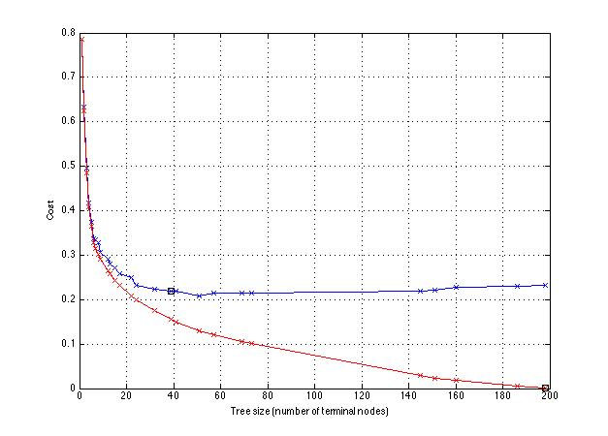
Figure 3.1 The cost curves against tree size on clean dataset

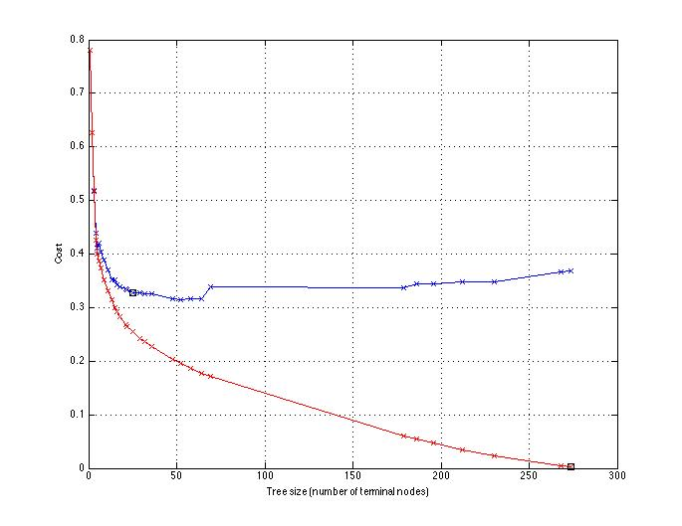
Figure 3.2 The cost curves against tree size on noisy dataset

In general, the red curves indicate the cost decreases when the tree size goes up and can reach 0 at full size. Since resubsistution method uses the same dataset for training and testing, the further the decision tree is trained, the better the training samples are fitted. The ID3 algorithm grows each branch of the tree just deeply enough to perfectly classify the training examples. It is very likely that the trees overfit the training data when the number of terminal nodes is large.

The blue curves show that the cost decreases as the tree size increases within a range, but then stabilizes and even goes up a little. The optimal costs of 10-fold cross validation on both clean dataset and noisy dataset are pointed out at the tree sizes of 40 and 25 respectively. What’s interesting is that they are local minimums in both blue curves, which means the treetest function seems to choose the first local minimal cost as the estimated best one. The increase of cost in cross validation sets imply the decision trees have suffered from overfitting, making the decision trees perform worse on unseen samples.

Comparing these 2 figures above, we can find that the red curve decreases more slowly on the noisy dataset than on the clean one. In figure 3.1 it approaches zero at the tree size 200 while in figure 3.2 it does not converge until 250. We speculate that this is because the noise is uncertain and such uncertainty causes difficulty in fitting the data, the decision will need more branches to approximate the target function. For the blue curve, it stabilizes at around 0.22 on the clean dataset but levels at 0.34 and even begins to go up on the noisy dataset. As what we talked in chapter 3.1, the noise in dataset could lead to the overfitting problem, so the decision tree trained from noisy training set performs worse when meeting a different test set. That’s no wonder why there is difference between two blue curves.

Reference
[1] Quinlan, J. Ross. "Induction of decision trees." Machine learning 1.1 (1986): 81-106.

4. Code Flowchart
Apply Nearest Neighbour Approximation
Y[i] = nearest_neighbour_ approximation (T,X[i])
Y[i] = random(1-6)
Y
N
End
i <= number of samples X
Y[i] = select the positive label witch has the lowest depth
Y[i] = select the positive label randomly
i=i+1
Predicted labels Y
Y
N
[labels_, depth_] = testTree(T,X[i],1)
All trees return negtive
Apply shortest-depth selecting
start
Decisoin trees: T
Testing samples: X
Strategy option: opt
i=1
N
N
Y
Y

Figure 4.1 Flow chart for function testTrees
Y
End
Predicted label:y
potential_labels is empty
select the label with lowest depths in potential_labels as y
Randomly select a label from 1-6 as y
Start
Decision trees: T
Testing sample: x
i=1
new_x = x with the i th attribute value inverted
[labels_, depths_] = testTree(T,new_x,1)
potential_labels=[]
potential_depths=[]
Add positive labels and their levels in [labels_,depths_] into [potential_labels,potential_depths]
i=i+1
i <= length(x)
N
Y
N

Figure 4.2 Flow chart for Nearest_Neighbour Approximation

start
Root node: t
Current depth: d=1
Sample x
If t is a terminal node
Find a branch of tree t corresponding to the specific attribute value of sample x
t = the new branch node
d = d+1
Output the class label y of terminal node and its depth d
End
Y
N

Figure 4.3 Flow chart for function testTree which test example using one decision tree

i=1
Load(fn,xs_train,ys_train,xs_test,ys_test)
Partition x and y into 10 subsets: sub_x(i),sub_y(i) , i=1:10
End
xs_test=sub_x(i)
ys_test=sub_y(i)
xs_train=[sub_x(1:i-1),sub_x((i+1):10)]
ys_train=[sub_y(1:i-1),sub_y((i+1):10)]
i=i+1
i >10?
save(fn,xs_train,ys_train,xs_test,ys_test)
i=1
Trees = learn(xs_train(i),ys_train(i))
Predicted_y = test(Trees,xs_test(i))

Calculate recall, precision,f1,classification rate,confusion matrix according to Predicted_y and ys_test(i)
i=i+1

i >10?
Output average recall, precision,f1,classification rate, confusion matrix
File named fn exist
Training examples: x
Labels of examples: y
Name of datasets: fn
Leanring function handle:learn
Testing function handle: test
Start
Y
Y
Y
N
N
N

Figure 4.4 Flow chart for function cross_validation10

5. Diagrams of Trees

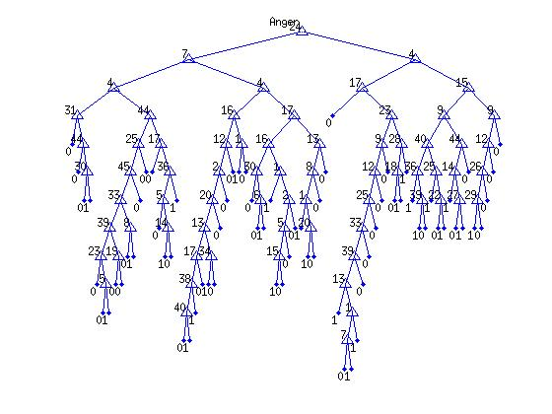

Fig 5.1 The decision tree for Anger

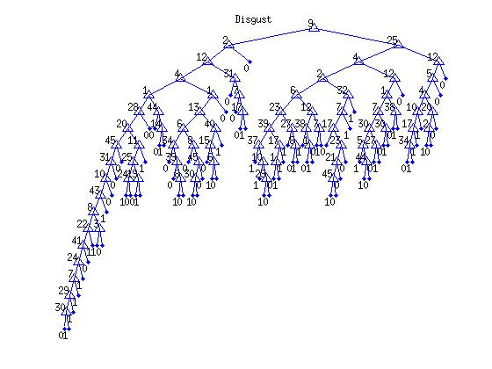

Fig 5.2 The decision tree for Disgust

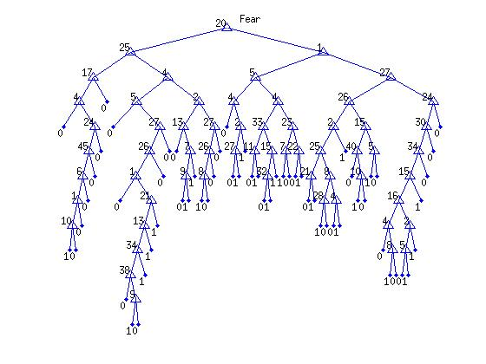

Fig 5.3 The decision tree for Fear

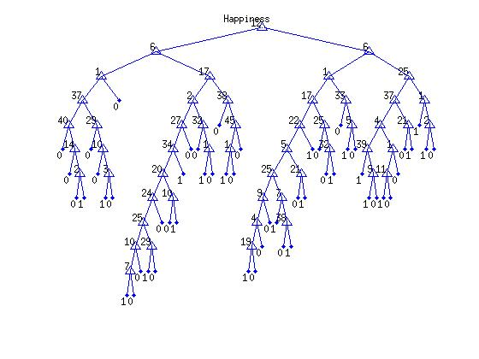

Fig 5.4 The decision tree for Happiness

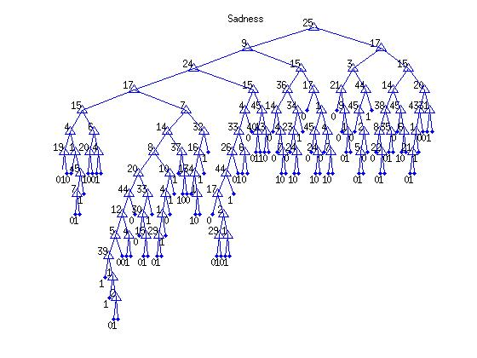

Fig 5.5 The decision tree for Sadness

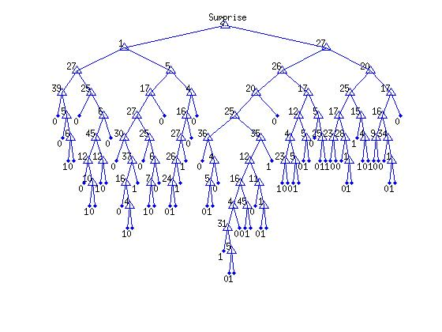

Fig 5.6 The decision tree for Surprise

